# **DECLARATION**

We, **BATAMURIZA Sunia and NTAKIRUTIMANA Abdoul Wahidi**, hereby declare that this project entitled “**ONLINE STATIONARY STORE MANAGEMENT** “we are responsible for the work submitted in this project, that the original work is our own effort and that the original work contained herein have not been undertaken or done by unspecified sources or persons.

**Names: BATAMURIZA SuniaNames:NTAKIRUTIMANA Abdoul Wahidi**

**Signature: ……………………… Signature: ………………..**

**Date: …………………. Date………………………….**

# **APPROVAL**

We, **BATAMURIZA Sunia** and **NTAKIRUTIMANA Abdoul Wahidi** hereby certify that this project has been done under his supervision and submitted with his approval.

**Approved by supervisor: Approved by Head of Department**

**Dr. KABANDANA Innocent Dr. KABANDANA Innocent**

**Signature: ……………………… Signature…………………..**

**Date: …………………. Date…………………………..**

# **DEDICATION**

WE DEDICATE THIS WORK

To our lovely families

To all our friends and relatives

And our classmates.

# **ACKNOWLEDGMENT**

First and foremost, we thank almighty God for his grace and protection during our studies. It was not easy to carry out this project without support from different people. we deeply give our thanks to the academic staff of the Department of computer science and the whole administration at the independent university of Kigali (ULK) for the knowledge they transferred to us.

would like to express a heartfelt thanks to Dr. KABANDANA Innocent as the Final Year Project supervisor for guidance and unwavering support. Without his help, this project might not be able to finish within the scheduled time.

A very special thanks to our family members for giving continuous support and encouragements throughout this project.

Finally, we would like to thank all other colleagues for lending a helping hand.

May God bless you all.

# **ABBREVIATIONS**

**CSS :** Cascading Style Sheet

**WWW** :World Wide Web

**HTML :** Hyper Text Markup Language

**IDE** : Integrated Development Environment

**DFD** : Data Flow Diagram

**OSS :**Online Stationery Store

**SQL :** Structured Query Language

**OS :** Operating System

**PHP** : Hypertext Preprocessor

**RDBMS :** Relational Database Management System

**ULK :** University Libre de Kigali

**UML :** Unified Modeling Language

**XHTML :** Extensible Hypertext Markup Language

**PP :** Product Price

**PU :** Unit Price

**SMS :** Short Message Service

**XML :** Extensible Markup Language

# **TABLE OF CONTENT**

**DECLARATION** i

**APPROVAL** ii

**DEDICATION** iii

**ACKNOWLEDGMENT** iv

**ABBREVIATIONS** v

**TABLE OF CONTENT** vi

**ABSTRACT** x

**CHAPTER I: GENERAL INTRODUCTION** 1

**1.1.** **Introduction** 1

**1.2. Background of the study** 1

**1.3. Problem statement** 2

**1.4. Objectives of the study** 3

**1.4.1. General objective** 3

**1.4.2. Specific objectives** 3

**1.5. Scope of the project** 3

**1.6. Project methodology** 4

**1.6.1. Observation** 4

**1.6.2. Interview** 4

**1.6.3. Documentation** 4

**1.7. Project schedule (Gantt chat)** 4

**1.8. Organization of the project** 5

**CHAPTER II: LITERATURE REVIEW** 6

**Introduction** 6

**2.1. Order overview** 6

**2.3. Review of existing Online Stationery Store Systems** 6

**CHAPTER III: SYSTEM ANALYSIS AND DESIGN** 8

**3.1 Introduction** 8

**3.2. Analysis of the current system** 8

**3.2.2. Problem of the current system** 8

**3.3. Analysis of the new system** 9

**3.4. System requirements** 9

**3.4.1. Functional requirements** 9

**3.4.2. Nonfunctional requirements** 10

**3.5. Design of the new system** 10

3.5.1. **System Design** 10

3.5.2. Function diagram 10

**3.6. DATA DICTIONARY** 17

**CHAPTER IV: IMPLEMENTATION AND TESTING OF THE NEW SYSTEM** 20

**4.1. Introduction** 20

**4.2. Technologies used** 20

**3.** **Cascading style sheets** 21

**4.** **PHP** 21

**5.** **HTML** 22

**6.** **I Text Report** 22

**4.3. Software Testing** 23

**4.4.** **The graphical interface of OSS** 24

**Stock** 31

**CHAPTER V: CONCLUSION AND RECOMMENDATIONS** 33

**5.1. Conclusion** 33

**5.2. Recommendations** 33

**References** 34

# 

# **LIST OF FIGURES**

Figure 1: System administrator diagram function 11

Figure 2:Employee diagram function 12

Figure 3: Admin table 14

Figure 4: Online customers table 15

Figure 5:Items table 15

Figure 6:Service table 16

Figure 7:Expenses table 17

Figure 8:Dashboard Page 25

Figure 9:Login Page 25

Figure 10:Admin Home Page 26

Figure 11:Items Page 27

Figure 12:Service Page 27

Figure 13:Expenses Page 28

Figure 14:Sell Page Expenses Page 28

Figure 15:User Profile 29

Figure 16:Online Customers 29

Figure 17:Goods Report 30

Figure 18:Service Report 30

Figure 19:Expenses report 31

Figure 20:Purchase History 31

Figure 21:Stock 32

Figure 22:Mini Statement 32

# 

# **LIST OF TABLES**

**Table 1: Gantt chat** 5

**Table 2:Symbols data flow diagram (DFD)** 13

**Table 3: admin** 17

**Table 4:Online** 17

**Table 5:Items** 18

**Table 6: Service** 19

**Table 7:Expenses** 19

# 

# **ABSTRACT**

Over the past few years, the Internet has played a very important role be it at home, work or school. Internet applications such as online shopping and online voting has been widely accepted worldwide.

This project focuses on the significance of online systems technology for managing ACER stationerystore, to enhance the systems from manual to online and to implement an integrated system. Different tools were used for analysis, design, and development of the system.

The project is being developed using server side scripting, PHP for developing the system and MySQL database, CSS to design style.

Using the manual system, ACER stationary store has to face a few problems such asdifficulties onmanaging stock, stationery report and stationery as well. By implementing a new web based systems those problems can beminimized as well assaving costofpurchasing papers.

# 

# **CHAPTER I****: GENERAL INTRODUCTION**

# **Introduction**

Online stationary store management system gives information to the costumers about our goods, services and their price tag, and also manage employees, report making,finances,loan.

For any stationery store, the administration contributes to the development of the stationery store and mission by providing informed decision-making regarding employees benefits by providing accurate, timely, accessible information. The Administration is responsible to give or block employees permission.

The current system requires an employee to manually make report that spend more time (writing report), money (papers, pens), overprice, the current system has no modern way of informing the customers about prices of goods and servicers the current system has a drawback where an employee must be waiting behind the door of the Administration for submitting report.

We aim to do the automated online stationery store management system of ACER that enable employees with capabilities to submit the report anytime via World Wide Web (www) and the Administrator will be enabled to control, manages and also communicate consistently with the employees regarding information of the work. Which is important because it will lead the employees to become a more maintainable and give better and clear services to the customers.

The main focus of our study will be on how online stationery store management system is to manage the employees, purchase and selling record, automatic report, and informing the customers about the goods& services price tag via Word wide web (www).

# **1.2. Background of the study**

The Internet is a worldwide system of computer networks, which is a network of networks in which users at any one computer can, if they have permission, get information from any other computer. Sometimes, it also enables user from one location talk directlyto users at other computers in a different location.

Today, the Internet is a public, cooperative and self-sustaining facility accessible to hundreds of millions of people worldwide. This is due to its importance in everyday life. For instance, it allows information transferring, information sharing as well as communication.

ACER stationery store needs to monitor and manages the employees. In this manner the administration must have the automated system to manage the business for the proper performance of the Employees. In the existing system the employees were required to use paper work in making report. At the end of the year the Administrator is supposed to go through those paper archives which take more time and also the risks of losing data are optimized. This online stationery management system is helpful to administrator tasks and keep the records regarding to his work of managing the business. And allow employees to have access to the system.

This system can be used to reduce the work of record keeping in books. The main idea is to create an automated website on world wide web(www) connected to database which will maintain employee or customers.

Once customers need any information about goods and services, he/she goes directly to the system via website, while employees need any access to the system have to login to make any sell or purchase and the administrator will make actions (management and view (reports)) with the description. The system will reduce a paper work and maintain recordings in a proper and efficient way.

# **1.3. Problem statement**

There are some problems where the administrator is not able to manage the business in a proper way and receive reports at the right time.

Manual system does not provide information to the clients entered about cost product where it’s require to go to the store to get the information, and loss of clients due to lack of information.

The current system uses paper work so that the employees have to write the report using paper pen method that could be the reason of losing information and waste of time.

# **1.4. Objectives of the study**

# **1.4.1. General objective**

The aim of this project is to build software that is web-based system. that can be able to achieve stationery store management system platform in an effective and efficient manner. This system will also facilitate data storage.

# **1.4.2. Specific objectives**

* To provide for an automated online stationery management system that intelligently adapts to administration policy of organization and allows employees to manage better scheduling of work load and processes.
* To decrease a paper work and enable the work with efficient, reliable record maintenance by using centralized database. Thereby reducing chances of data loss.
* To make easier for employee to make automatic reports.
* To make a completely secured web-based system.
* To enhance the systems from manual to online.

# **1.5. Scope of the project**

The scope of the project is limited to several processes: managing of employee, managing purchase sales, reports management and store management. It will also generate employee’s availability, permission (access to the system),The system is designed to be easily navigated by users. Users will have the flexibility to use the system as it is user friendly and easy to understand

The accuracy can also be greatly improved when converting to the online system. This is due to all information will be stored in a database and will be properly managed.

# **1.6. Project methodology**

To conduct research, we need data collection. Data collection is one the most important stage in conducting research. you can have the best research but if you cannot collect the required data you will not be able to complete project objectives.

There are many methods to collect data, depending on research design and methodologies employed. Some of the common methods are questionnaires, documentation, interview, and observation. In this project the following techniques were used to understand the manual existing system:

# **1.6.1. Observation**

Observation is a way of gathering data by watching behavior, events, or noting physical characteristics in their natural setting. The observation will be indispensable to collect data on the actual work reality. I have used this one to observe what happens in ACER papeterie

# **1.6.2. Interview**

It is defined as a systematic conversation between an investigator (interviewer) and an informant (interviewee), initiated for obtaining information relevant to a specific study. I have used this to interview the owner and some employees about the current system.

# **1.6.3. Documentation**

The documentation is oriented towards a systematic evaluation of all writings linked with the research domain and it helped me to collect useful documents, archive reports related to ACER papeterie.

# **1.7. Project schedule (Gantt chat)**

A Gantt chart is a type of bar chartthat illustrates a project schedule. This chart lists the tasks to be performed on the vertical axis, and time intervals on the horizontal axis. The width of the horizontal bars in the graph shows the duration of each activity. Gantt charts illustrate the start and finish dates of the terminal elements and summary elements of a [project](https://en.wikipedia.org/wiki/Project). Gantt charts are usually created initially using an early start time approach, where each task is scheduled to start immediately when its prerequisites are complete.

**Table 1: Gantt chat**

|  |  |  |  |  |  |
| --- | --- | --- | --- | --- | --- |
| **Activity** | **Timeline** | | | | |
|  | August  2020 | September  2020 | October  2020 | November-December  2020 | January  2021 |
| Chapter one |  |  |  |  |  |
| Chapter two |  |  |  |  |  |
| Chapter three |  |  |  |  |  |
| Chapter four |  |  |  |  |  |
| Chapter five |  |  |  |  |  |

# **1.8. Organization of the project**

We cover five chapters:

Chapter1: introduction

Chapter2: literature review

Chapter3: system analysis and design

Chapter4: system implementation

Chapter5: conclusion and recommendation

# **CHAPTER II****: LITERATURE REVIEW**

# **Introduction**

This chapter is about studies and literatures that are related to the online stationery store system that the proponents made use of different reading materials (such as thesis, articles, and other Web articles) that will be extending the knowledge of the proponents. These reading materials will also guide the proponents to improve and develop their proposed system more effectively.

# **2.1. Order overview**

An Order is an [arrangement](https://www.collinsdictionary.com/dictionary/english/arrangement) that you make when you book something like (pens, file folder) then administrator approve it.

In short, an online stationery store system is a system which enables customers to order the product online in the form of business. With an online stationery store system, administrator and employees alike are in control of services, goods and available products that are ordered by clients. Setting buffer time and configuring recurring appointments is also possible with many systems. Advanced ordering programs will also allow you to set up a customized and branded ordering page, as well as send out automated reminders via SMS and EMAIL.

But in this system ordering is related to the products we have in ACER Stationery store management

# **2.3. Review of existing Online Stationery Store Systems**

ACER stationery store company deploys school materials for their clients.employees are prompted to come to explain, show and do the registration of clients and to enter the details of client such as phone number and then calculate the amount of money a client is going to pay and prepare the reports using handwriting and leave it at work without knowing if the report can also be lost before received by the person in charge.The limitations of this system are that the clients comes to the store without knowing if the products are available at that time and also to know the prices of the product .

* **Similarities and difference between the existing system and the proposed new system is:** the existing system and the proposed new system both the clients must come to the store to take the product.
* **The different between them are:** the proposed system the ordering of clients have to been seen by the admin and then admin inform the employees about the command ordered by the clients through their electronic devices via world wide web(www) and also the client should receive notifications message via phone and Email, the amount to be payed will automatically be calculated.
* Short message service (SMS)

Is a text messaging service component of phone, web, or mobile communication system.

It uses standardized communications protocols to allow fixed line or mobile phone devices to exchange   
exchange short text messages (heather, 2012).  
The term "SMS" was used for both the user activity and all types of short text messaging in  
many parts of the world. SMS is also employed in direct marketing also known as sms  
marketing.

# **CHAPTER III: SYSTEM ANALYSIS AND DESIGN**

# **3.1 Introduction**

Systems are created to solve problems, one can think of the systems approach as an  
organized way of dealing with a problem. In this dynamic world, the subject system analysis  
and design mainly deals with the software development activities.

This chapter will present first the organizational structure and it is focuses on the study of existing system, making analysis in order to improve its functionality.

The new system comes to solve the existing problems in functionality of the old system. Assuming that the new system is developed, the next step is system analysis involved at detailed study of the current system, reading to specifications of new system.

# **3.2. Analysis of the current system**

**3.2.1. Introduction**

The analysis of the current system at stationery store management. Was formed of paper work so that administrator can faces a problem of managing the business.

# **3.2.2. Problem of the current system**

Let’s look into some of the most difficult challenges that an administrator faces by using the manual stationery store management systems. Some of the challenges are as follows:

* Waste of papers: ACER stationery store has also been wasting many papers as all request forms are in hard copies. Without realizing, a large amount of papers has been wasted for the purpose of producing stationery report forms.
* Waste of time: It has caused a great waste of time since there are a few procedures that are needed to follow before the goods items were finally received. It will become worse if the administrator is out of office as the employee will have to wait for some time before knowing their approval status. It is clear that the current system is very time consuming.
* Data misplaced or dismiss: Since the form is just a piece of paper, it might be easily misplaced or missed. Employee will need to make another report if the form is misplaced or missed.
* Lack of customers/ clients: the customers may not know which product we have and how many it cost.

## **3.3. Analysis of the new system**

The analysis phase answers the questions of who will use the system, what the system will do, and where and when it will be used.

Considering the existing problems of the online stationery store management, we have come up with a web-based solution, ACER online stationery store can save costs by not wasting papers, can save a lot of money by not purchasing extra papers for the purpose of producing stationery request forms.

Since all reports will be submitted online, all important data regarding requester will be stored in a database. Loss of data can be minimized, and increase client more than before.

**3.4. System requirements**

A system requirements analysis is a complete description of the behavior of the system to be developed; it includes a set of use cases that describe all of the interactions that the clients will have with the system. In addition to use cases, the system requirement analysis contains functional requirements, which define the internal workings of the system and non-functional requirements; the latter expressing the levels of safety, security, reliability, etc., that will be necessary

**3.4.1. Functional requirements**

A functional requirement defines the internal workings of the system, and its component, where a function is described as a specification of behavior between outputs and inputs. The following are the functional requirement of online stationery management system:

* This system allows the admin to login with username and password
* Login form where employees enter his/her username and password to be able to perform activities.
* This system allows the admin to add a USER details
* This system allows the admin to control and view reports.
* This system allow client to view our product via www
* This system allows user to add or remove goods&services, sell, and loan in the system.

**3.4.2. Nonfunctional requirements**

All those nonfunctional requirements or the services that are delivered to the customers are delivered in good way and effective where there are:

* **Usability:** this is system can be used by any user because interfaces in it are easy to learn and navigate.
* **Security:** each user has his/her own username and password, the system ensures that everyone who is connected to the system is known, the simple employee can’t access as administrator.
* **Maintainability:** the system can be modified to be correct fault, improve performance, and adapt to a changed environment.
* **Portability**: online store management system shall run in any browser

**3.5. Design of the new system**

## 3.5.1. **System Design**

System design is the process of defining the architecture, modules, interfaces, and data for a system to satisfy specified requirements. System design could be seen as the application of systems theory to product development. System design provides sufficient detailed data information about system and its system elements to enable the implementation consistent with architectural entities.

## 3.5.2. Function diagram

Function diagram is a graphical language for programmable logic controller design that can describe the function between input variables and output variables. A function is described as a set of elementary blocks. Input and output variables are connected to blocks by connection lines.

Here is the diagram that shows all function of **online stationery store system**

* **System administrator diagram function**

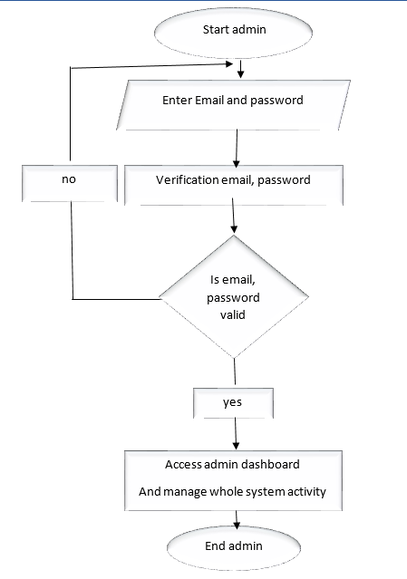

**Figure 1: System administrator diagram function**

* **Employee diagram function**

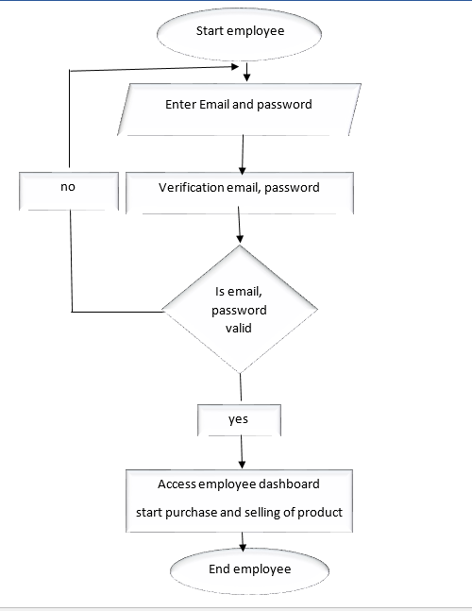

**Figure 2:Employee diagram function**

* **Data flow diagram**

Much in object oriented development, data flow diagrams were essential parts of pre-object oriented software development. Data flow diagrams (DFDS) still have an important role in the specification of many systems. The importance of data flow diagrams is in specifying what data is available to a component. Knowing the data available often helps in the understanding of what a component is expected to do and how it will accomplish the task.

A data flow diagram (DFD) is a graphical representation of data through informative system.

Data flow diagramming is a highly effective technique for showing the flow of information through a system. Data flow diagrams (DFD) are used in the preliminary stages of systems analysis to help understand the current and to represent a required system

**Table 2:Symbols data flow diagram (DFD)**

|  |  |  |
| --- | --- | --- |
| **Symbols** | **Names** | **Function** |
|  | **Process** | Show a manipulation of data within system |
|  | **Data flow** | Show the flow of information from its source to its destination |
|  | **External entity** | The source or destination of data outside the system. |
|  | **Data store** | Placeholder of storing information. |

Here is a list of table that have been used in the database.

**Admin table**

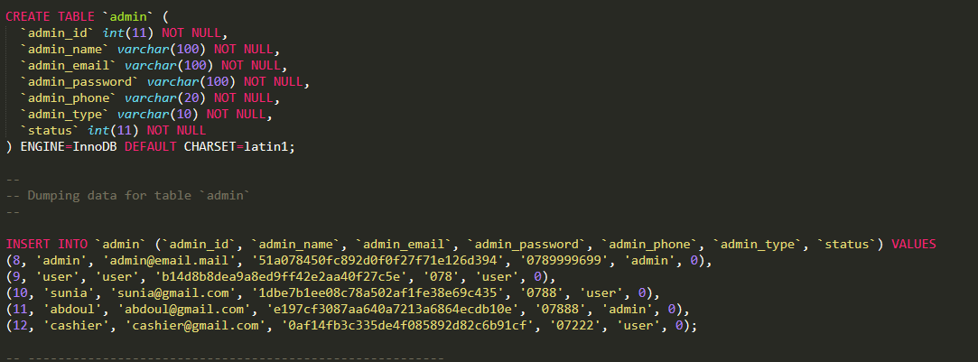

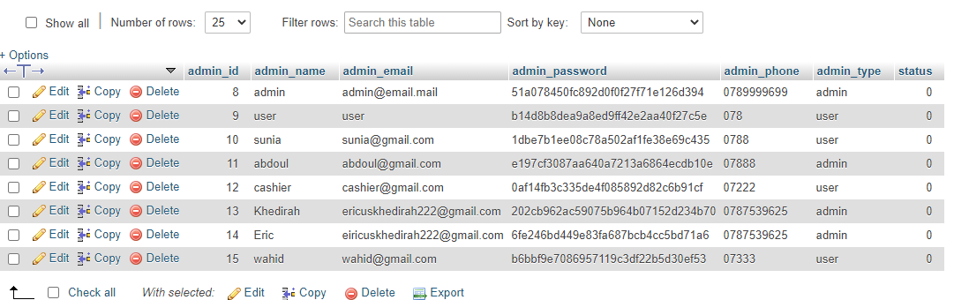

**Figure 3: Admin table**

**Online customers table**

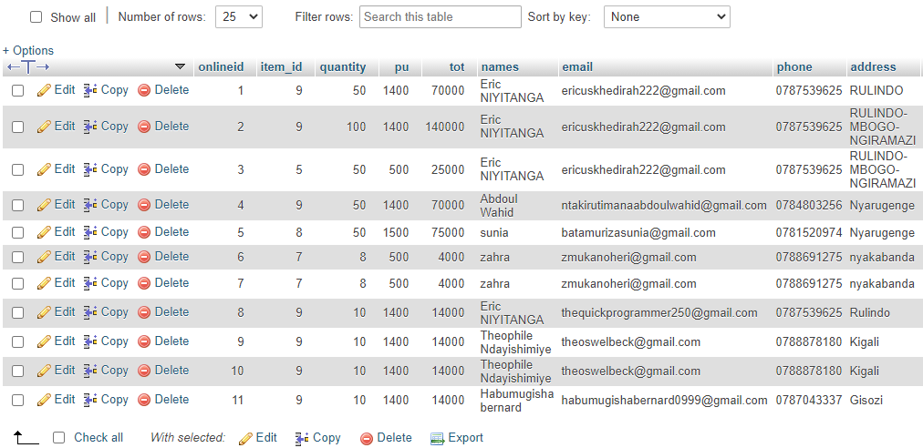

**Figure 4: Online customers table**

**Items table**

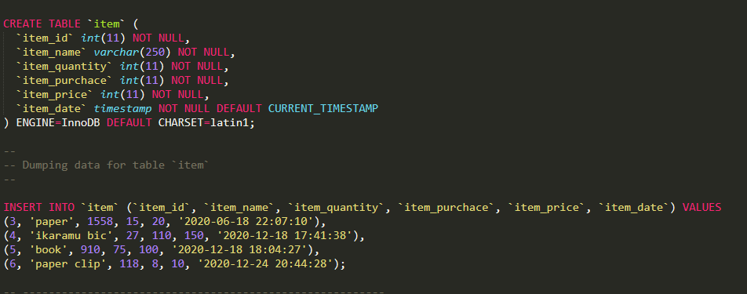

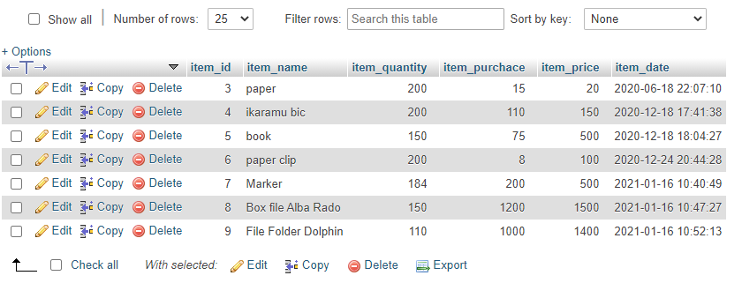

**Figure 5:Items table**

**Service table**

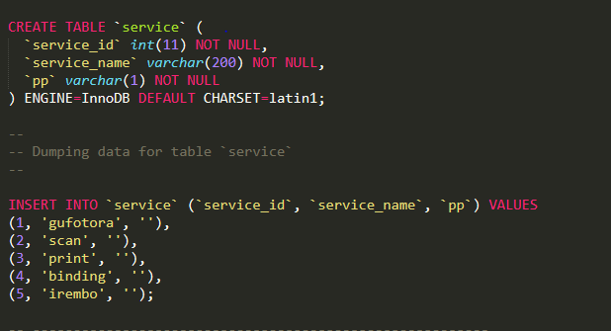

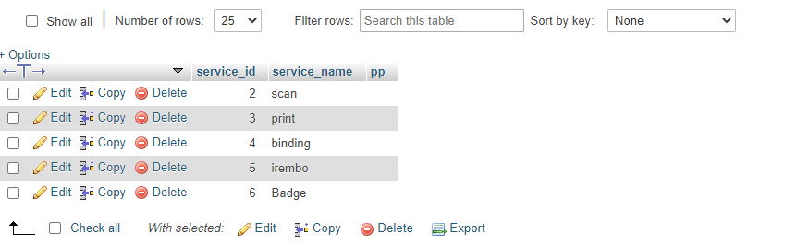 **Figure 6:Service table**

**Expenses table**

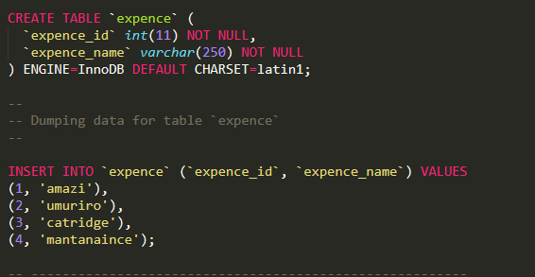

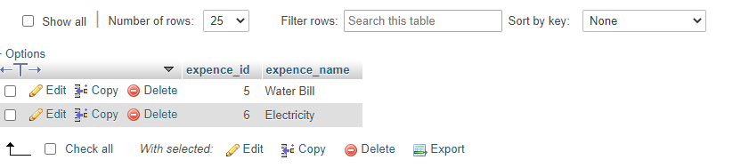  
**Figure 7:Expenses table**

# **3.6. DATA DICTIONARY**

**Table 3: admin**

|  |  |  |  |
| --- | --- | --- | --- |
| **Column** | **Type** | **Null** | **Comments** |
| Admin_id (Primary) | int(11) | No | Admin identification |
| Admin_name | varchar(100) | No | Admin name |
| Admin_email | varchar(100) | No | Admin email |
| Admin_password | varchar(100) | No | Admin password |
| Admin_Phone | varchar(20) | No | Admin phone number |
| Admin_type | varchar(10) | No | Admin type |
| Status | Int(10) | No | Status of admin |

**Table 4:Online**

|  |  |  |  |
| --- | --- | --- | --- |
| **Column** | **Type** | **Null** | **Comments** |
| online_id (Primary) | Int(11) | No | Online customers identification |
| item_id | Int(11) | No | item identification |
| Quantity | Int(11) | No | Quantity of items |
| Pu | Int(11) | No | Price per unit |
| Tot | Int(11) | No | Total price |
| Names | varchar(100) | No | Names of the customer |
| Email | Varchar(100) | No | Email of the customer |
| Phone | Varchar(10) | No | Customer phone number |
| Address | Text | No | Address of customer |
| Paystatus | Varchar(10) | No | Status of payment |
| Feedback | varchar(100) | No | Feedback messages |

**Table 5:Items**

|  |  |  |  |
| --- | --- | --- | --- |
| **Column** | **Type** | **Null** | **Comments** |
| item_id (Primary) | Int(11) | No | Item identification |
| item_name | Varchar(250) | No | Name of items |
| item_quantity | Int(11) | No | Quantity of items |
| item_purchase | Int(11) | No | Purchase amount of an item |
| item_price | Int(11) | No | Price of an item |
| item_date | Timestamp | No | Date of item purchase |

**Table 6:Service**

|  |  |  |  |
| --- | --- | --- | --- |
| **Column** | **Type** | **Null** | **Comments** |
| service_id (Primary) | Int(11) | No | service identification |
| Service_name | Varchar(200) | No | Name of service |
| Pp | varchar(1) | No | Service price |

**Table 7:Expenses**

|  |  |  |  |
| --- | --- | --- | --- |
| **Column** | **Type** | **Null** | **Comments** |
| expense_id (Primary) | Int(11) | No | expense identification |
| expense_name | Varchar(250) | No | Name of expense |

# **CHAPTER IV:** **IMPLEMENTATION AND TESTING OF THE NEW SYSTEM**

# **4.1. Introduction**

This chapter describes the development of the “*Online stationery store system*”. It includes a brief overview of the technologies used to make the application, operation, tests that have been applied. Last but not least, software and hardware compatibility requirements.

# **4.2. Technologies used**

To develop this application, I have used different technologies and tools namely:

* **My SQL**: for the creation of the database.
* **XAMMP**: for writing and compile codes.
* **CSS**: for the conception of the graphic interface creation and allowing the users to interact with the system and to control the look and provide efficiency to our web application.
* **I Text**: for the generation of the reports.

1. **My SQL**

MYSQL is a software development tool used to develop a database as a collection of data. The purpose of a database is to store and retrieve related information. (WELLING, 2013). To manage all of the data of related to Trust Industry have used database to make it possible.

1. **XAMMP**

XAMMP is an application that software developers use to create, debug, maintain, or otherwise support other programs and applications. XAMPP is a software development tool which is an open-source integrated development environment which supports the development of all Java application types (Desktop Application, web application). (Dantas, 2017)

To generate user interfaces, we have used PHP technology. PHP technology enables Web developers and designers to rapidly develop and easily maintain, information-rich, dynamic Web pages that leverage existing business systems.

As part of the PHP technology family, PHP technology enables rapid development of Web-based applications that are platform independent. PHP technology separates the user interface from content generation, enabling designers to change the overall page layout without altering the underlying dynamic content.

1. **Cascading style sheets**

Cascading style sheets are used to format the layout of Web pages. They can be used to define text styles, table sizes, and other aspects of Web pages that previously could only be defined in a page's HTML

Cascading style sheets are used to format the layout of Web pages. They can be used to define text styles, table sizes, and other aspects of Web pages that previously could only be defined in a page's HTML.CSS makes it easy to change styles across several pages at once. For example, a Web developer may want to increase the default text size from 10pt to 12pt for fif.ty pages of a Web site. If the pages all reference the same style sheet, the text size only needs to be changed on the style sheet and all the pages will show the larger text. (Etemad, 2015)

1. **PHP**

It is a server-side component-based user interface framework. It is used to develop web applications. It provides a well-defined programming model and consists of rich API and tag libraries. The latest version PHP lets as its default templating system. It is written in PHP.

The PHP provides components (input Text, command Button, etc.) and helps to manage their states. It also provides server-side validation, data conversion, defining page navigation, provides extensibility, supports for internationalization, accessibility, etc.

The PHP Tag libraries are used to add components on the web pages and connect components with objects on the server. It also contains tag handlers that implement the component tag. With the help of these features and tools, you can easily and effortlessly create the server-side user interface.

1. **HTML**

HTML is an interpreted computer programming language. It was originally implemented as part of web browsers so that client-side scripts could interact with the user, control the browser, communicate asynchronously, and alter the document content that was displayed

JavaScript is a prototype-based scripting language that is dynamic, weakly typed, and has first-class functions. Its syntax was influenced by the language C. JavaScript copies many names and naming conventions from Java, but the two languages are otherwise unrelated and have very different semantics. The key design principles within JavaScript are taken from the self and Scheme programming languages. It is a multi-paradigm language, supporting object-oriented, imperative, and functional programming styles.

JavaScript's use in applications outside of web pages (for example, in PDF documents, site-specific browsers, and desktop widgets) is also significant. (Ford, 2017)

HTML is written in the form of HTML elements consisting of tags enclosed in angle brackets (like <html>), within the web page content. HTML tags most commonly come in pairs like <h1> and </h1>, although some tags, known as empty elements, are unpaired, for example <img/>.

In between these tags, web designers can add text, tags, comments and other types of text-based content.

The purpose of a web browser is to read HTML documents and compose them into visible or audible web pages. The browser does not display the HTML tags but uses the tags to interpret the content of the page. (Aronson, 2016)

1. **I Text Report**

A report is a nicely formatted way of presenting the data that you have entered; reports are all about querying a database and displaying the results in a nice format. I text Report is an open-source Java reporting tool that can be used in Java-enabled applications, including web applications, to generate dynamic content. It has the ability to deliver rich content in various formats such as PDF, HTML, XML files, or directly on the screen or printer.

I text Report is a content-rendering library, not a standalone application. It cannot run on its own and must be embedded in another client or server-side Java application. Itext Report is a pure Java library and can be used on any platform that supports Java. Because Itext Report is a library and cannot run on its own, you do not really install it. “Installing” Itext Report simply means downloading its JAR file and putting it into the Class path of your application along with the other required JAR files.

Generating reports is common, if not always glamorous, a task for programmers. In the past, report generation has largely been the domain of large commercial products. Today, the open source I text Reports report generating library gives Java developers a viable alternative to commercial software. I text Report provides the necessary features to generate dynamic reports, including data retrieval using JDBC (Java Database Connectivity), as well as support for parameters, expressions, variables, and groups. (Lowagie, 2007)

# **4.3. Software Testing**

Software tests play an important role in software designing. They help to verify the effectiveness of the software to see if it actually does what it was supposed to solve.

Listed are key aspects to take into consideration in software testing

* Does the application meet the requirements that guided its design and development?
* Does the application work as expect?
* Can the application be implemented with the same characteristics and satisfies the needs of the users?

The following are some software testing

* **The Unit Test:** Unit testing is a process to ensure the proper function in a particular software or a portion of a program. It is a method by which individual units of the source code, sets of one or more computer program modules together with associated control data, usage procedures, and operating procedures, are tested to determine if they are fit for use. In other words, every small component that can be compiled with the goal to know that every unit matches to its specifications, and to know if there are logical mistakes.  Indeed, the unit test is an effective means that permits to detect the maximum possible mistakes. The application has been checked with the unit test at each piece of the code written. (Bos, 2005)
* **The Integration test**: is the phase in software testing in which individual software modules are combined and tested as a group. This test is used to check the assembly of the different part of the software. It is also a progression of tests, in which the software and hardware components are collected and tested until the entire system is tested. The application modules have been successively tested until completion to ensure that the whole constituted by the assembled software components answers to the required functional and technical specifications. (Charles, 1986)
* **The Validation test:** The last test phase has the role of validating the software in its external environment. The product has been put in a final situation in order to verify if it perfectly answers to the needs expressed in the first phase. The validation test is important since it is necessary to verify if the setting up of the application corresponds to the expressed needs. The application has been tested in its entirety, and it is in this way that we noticed that the progress of operations done corresponds to the functional specifications. (Roldan, 2003)

# **The graphical interface of OSS**

**Dashboard Page**

This dashboard page display homepage

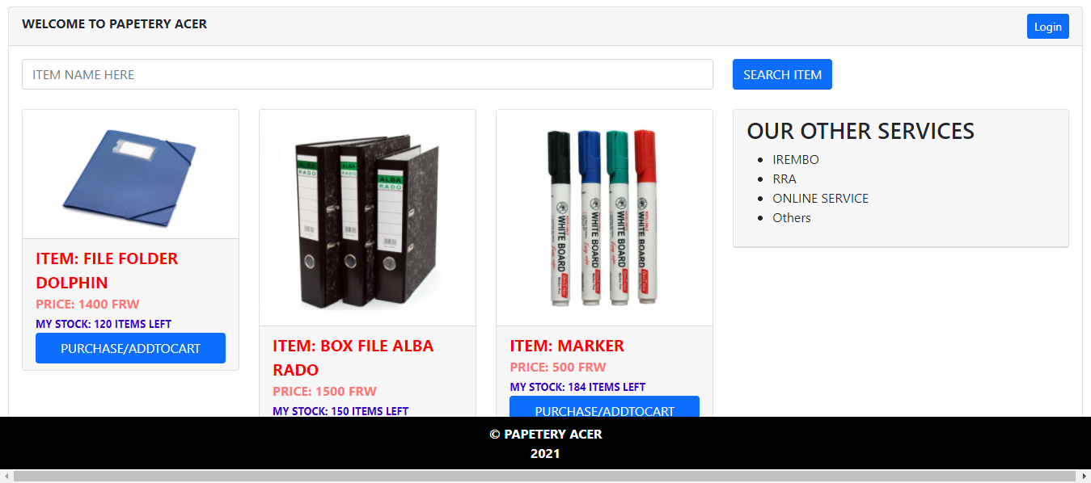

**Figure 8:Dashboard Page**

**Login Page**

Allows the employees and administrator to enter the system

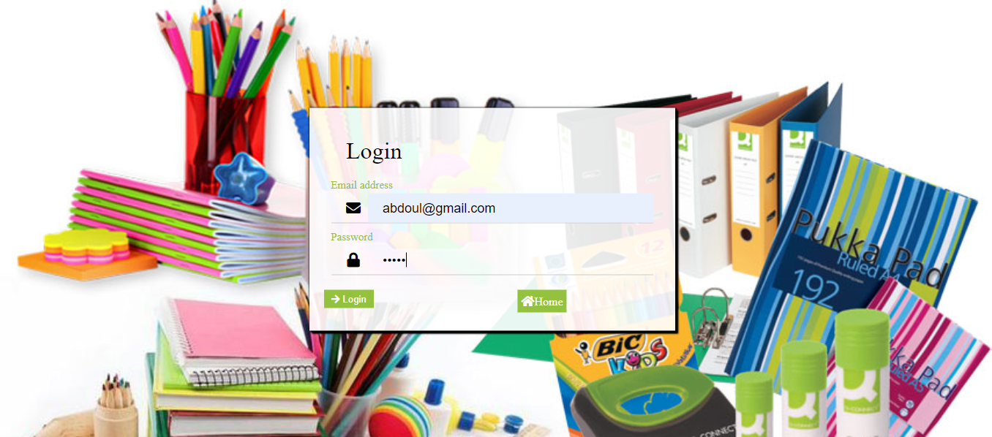

**Figure 9:Login Page**

**Admin Home Page**

allows the admin to purchase, view the report and manage the employees.

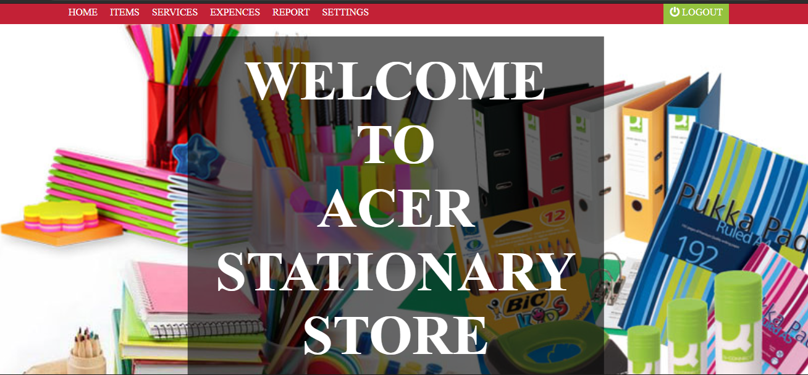

**Figure 10:Admin Home Page**

**Items Page**

Add new items and their prices in the system.

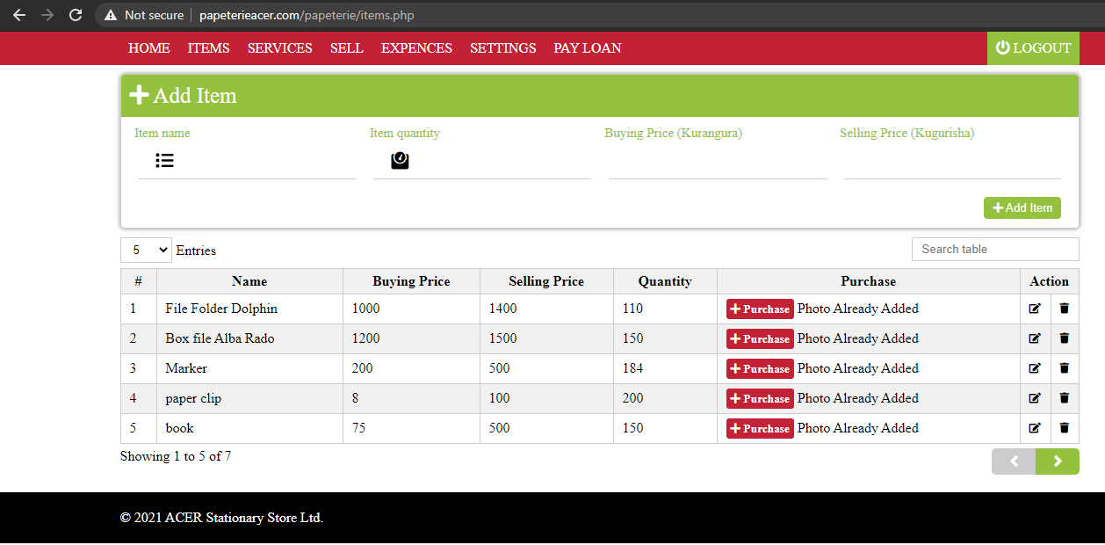

**Figure 11:Items Page**

**Service Page**

Add/edit services and their cost.

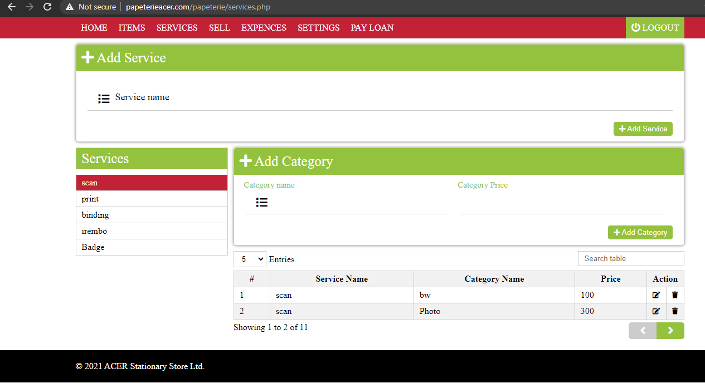

**Figure 12:Service Page**

**Expenses Page**

Add/edit expenses and their cost prices.

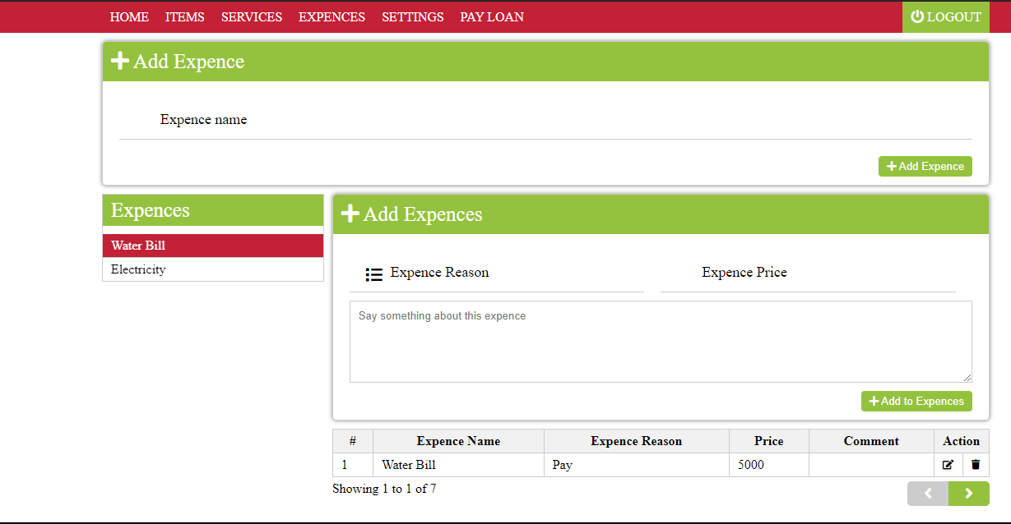

**Figure 13:Expenses Page**

**Sell PageExpenses Page**

This page allows to enter selling records.

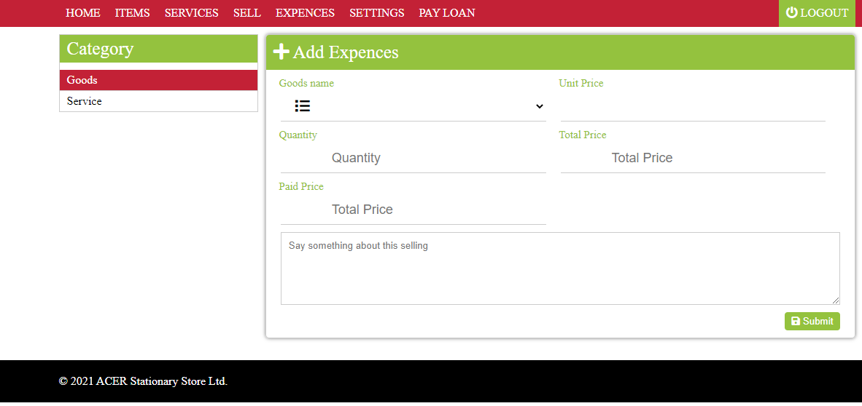

**Figure 14:Sell Page Expenses Page**

**User Profile**

This page allows the user to update names, email, phone and password.

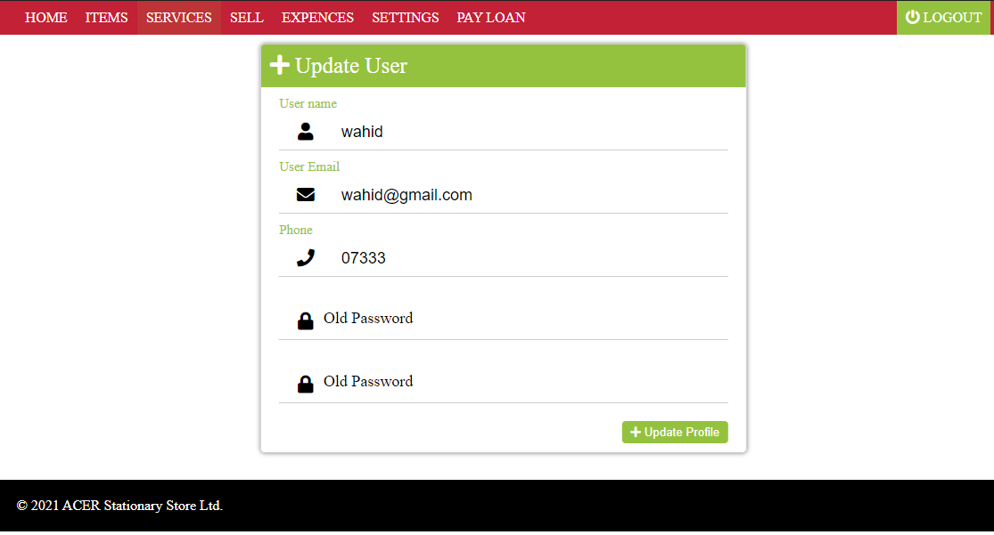

**Figure 15:User Profile**

**Online Customers**

This page shows customers who ordered the product.

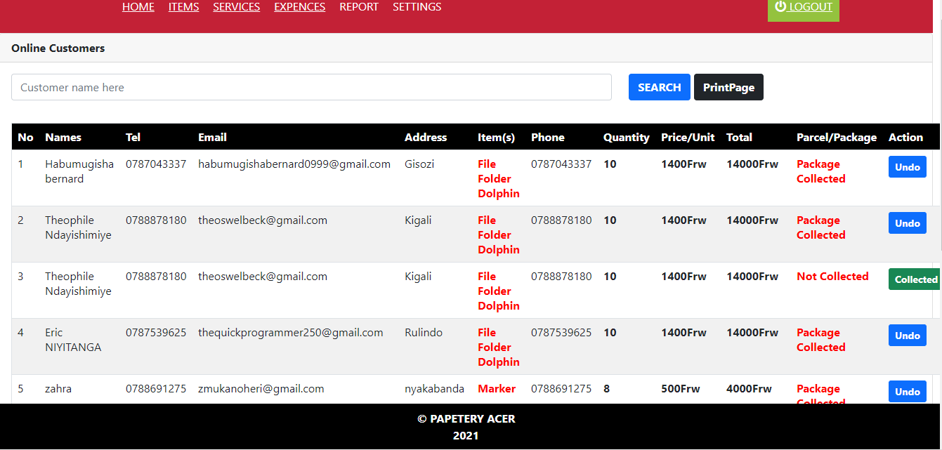

**Figure 16:Online Customers**

**Goods Report**

Report of goods sold

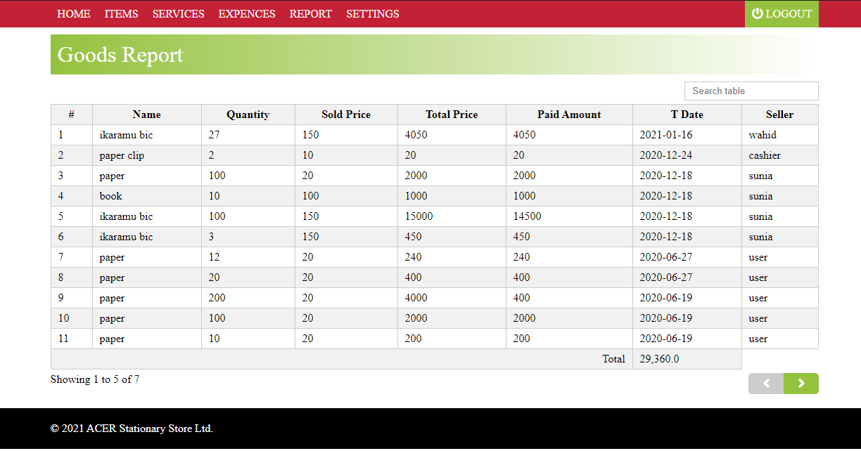

**Figure 17:Goods Report**

**Service Report**

This allows the admin to view the services they sold

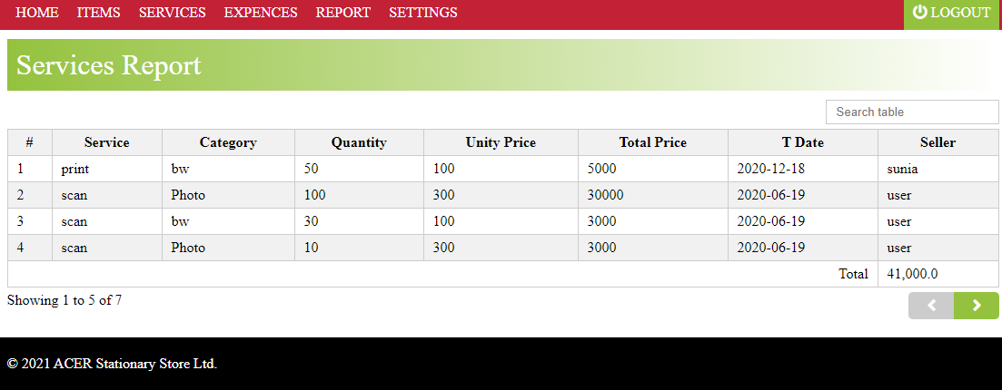

**Figure 18:Service Report**

**Expenses report**

This page shows the expense used.

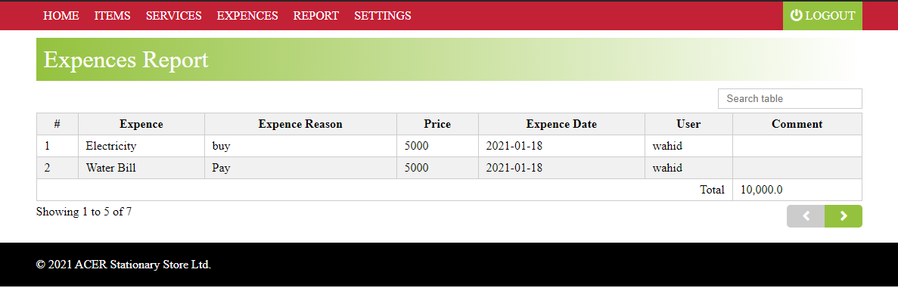

**Figure 19:Expenses report**

**Purchase History**

This page shows the report of purchased products.

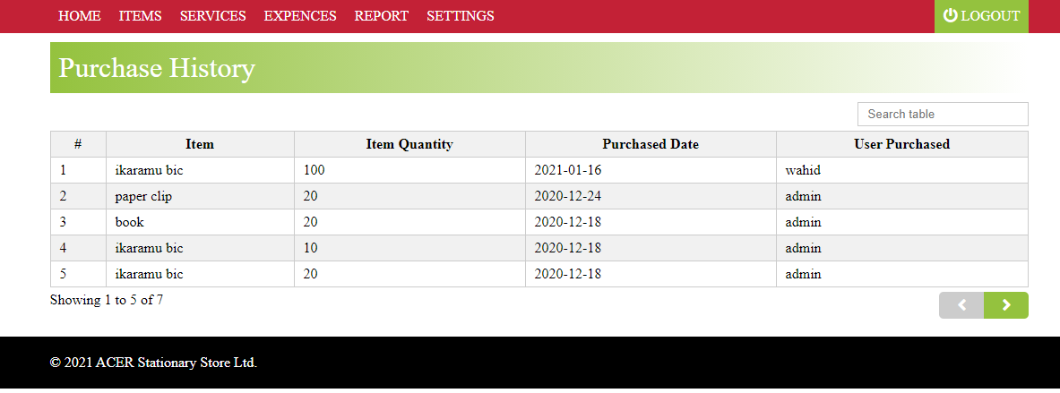

**Figure 20:Purchase History**

# **Stock**

This page shows the report of our stock.

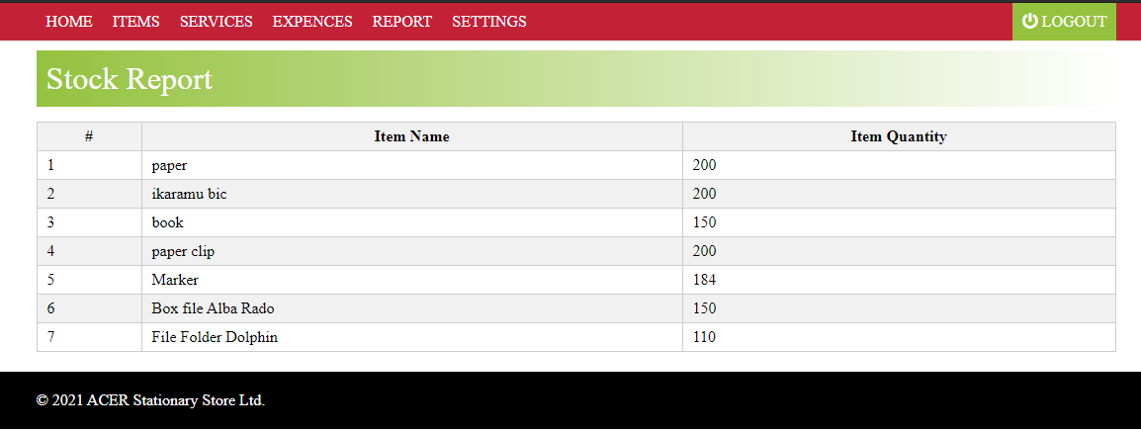

**Figure 21:Stock**

**Mini Statement**

This page shows the entire report.

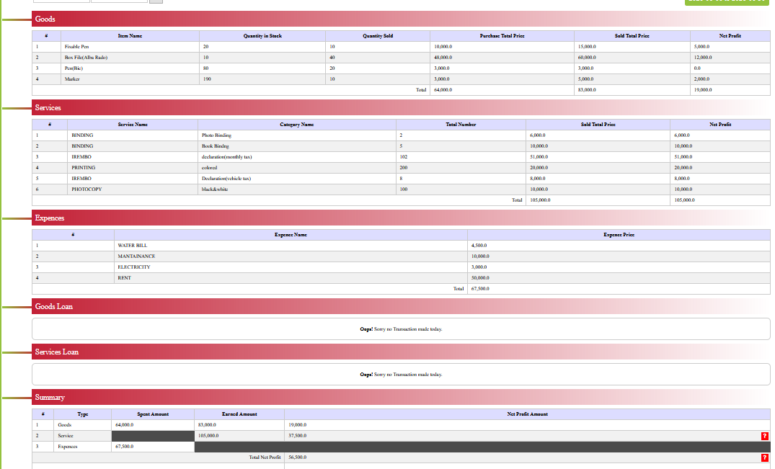

**Figure 22:Mini Statement**

# **CHAPTER** **V: CONCLUSION AND RECOMMENDATIONS**

# **5.1. Conclusion**

The aim of this project has been successfully achieved. The online stationery management system for managing stationery store business and informing the clients about product prices via world wide web(www) has been properly designed and implemented. The design was done using UML approach and iterative model. The implementation was done using Hypertext Pre-processor (PHP), Hypertext Markup Language (HTML) and Cascading Stylesheet (CSS). Online stationery store Management System is very useful for ACER stationery store to maintain the sales record and management of employees. This system not only maintains the sales record and management of employees; it also informs the clients about the product prices via world wide web(www). The higher authority (administration) may view the report, purchase products and manage users of the system (add or remove), this system maintains management of loan given to the clients and employee who loaned.

# **5.2. Recommendations**

* The system will be a web application that provides information to the client about goods and services price.
* We would recommend ACER stationery store to take advantage of this system for them to keep records, also inform the clients and manage employees.
* We recommend also open doors for others to add more functionalities whereby the system will totally make easy the work of administration and sales.
* In closing this work, we leave the door open to anyone who would like to add, improve or perform further research on this topic.
* We would to recommend ACER Stationery store to add the report of each and every product in the store (pens, books, ….) after the system is on the market.

# **References**

**Websites**

* [www.fadu.co.rw](http://www.fadu.co.rw|)
* <https://www.imdb.com/title/tt0450581>
* <https://www.managementstudyguide.com/charles-handy-model.html>
* www.xampp.org: https://www.xampp.org/features/

**Books**

* Bos, B. (2015). *Cascading Stylesheet designing for the web third Edition.* Canada: Addison Wesley.
* Coronel, C. (2016). *Database Systems.* Mexico: Cengage Learning.
* Wixom, B. H. (2011). *System Analysis and Design Fifth Edition.* USA: Don Fowley.
* Ford, N. (2017). *Guide to Building Intelligent Web Sites with ph.* New York: John Wiley & Sons, Inc.